**ASSIGNMENTS DIGITAL MARKETING**

**NAME** : C. Vino Priyadharshini

**DEPARTMENT** : Computer Science and Engineering

**COLLEGE** : Dhanalakshmi Srinivasan institute of technology

**NAANMUDHALVAN COURSE** : DIGITAL MARKETING

**TEAM ID** :NM2023TMID03435

ASSIGNMENTS ON DIGITAL MARKETING

1.Create a blog or website using Blogspot and WordPress. Customize the theme design and post new article with

500 words.

Blogspot : <https://zenvogue111.blogspot.com/2023/08/about-textiles-marketing.html>

Wordpress: <https://wordpress.com/post/zenvogue.wordpress.com/8>

2.Create a New Facebook buisness page and post one social media poster for your brand.

Facebook link: <https://www.facebook.com/zenVogue111>

3.Create and design a social media posture using canva.

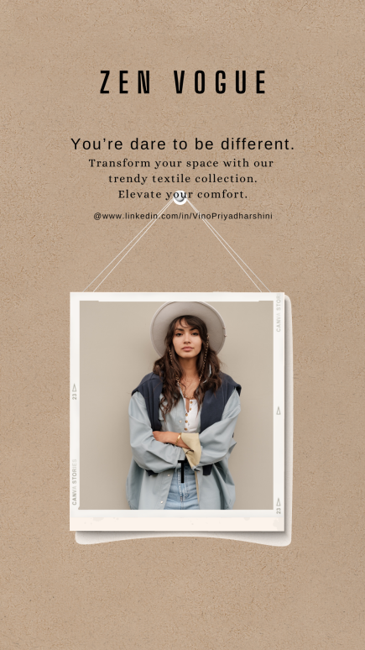

4.Create a Email newsletter design using MailChimp or canvatool.

